Chapter 8, Problem 60.

Obtain i₁ and i₂ for t > 0 in the circuit of Fig. 8.106.

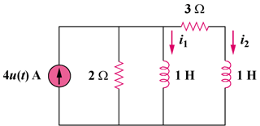

Figure 8.106
For Prob. 8.60.

